Long Covid – What Matters to You?
Survey Response Summary Report
4th January 2022

Distribution
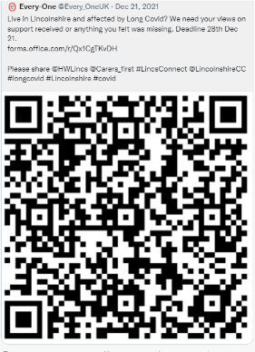
The survey was distributed via a wide range of networks formal and informal including:
- Lincolnshire Long Covid Co-production Group Members
- Social Media – Twitter and Facebook
- Lincolnshire NHS Trusts including direct to patients via key the Post Covid Service
- Lincolnshire County Council
- Voluntary Sector Organisations
- Lincolnshire Military, Veterans & Families Wellbeing Network

Time Frames
Responses were received between 15th December 2021 and 29th December 2021

Number of Responses
50 responses were received in total.
38 = has long covid
6 = has had long Covid
4 = works with people who have / have had long covid
2 = family member / friend of someone who has / had had long covid

Proposed Priorities
Participants in the survey, on the whole, were in agreement with the four priorities that had been proposed by the Lincolnshire Long Covid Co-production Group.
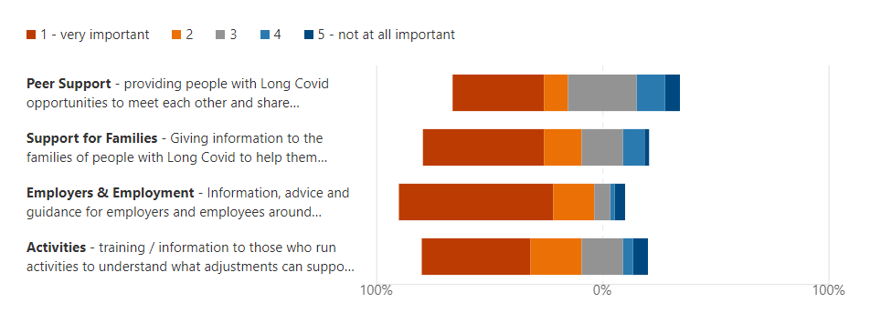

Other Priorities
20 of the 50 respondents felt there were other priorities that needed to be addressed to help those experiencing Long Covid, whilst 14 said there may be other priorities. 16 people did not feel there were any other priorities that needed addressing.


The respondents identified the following as possible activities/priorities to be explored as part of the project for which NHS Charities Together funding is sought:

- information/guidance/training for GPs & nurses on LC/PC and its impacts (potential for identification of ‘Covid Champion’ within GP practice);
- upskilling of Expert patients/volunteers/social prescribers;
- information/guidance for schools;
- information/guidance for employers;
- development of specific groups e.g. breathlessness, chronic fatigue, exercise and/or local peer support groups;
- development of covid clinic/advice line – heart, lung, stomach, pain management, physiotherapy, mental health, chronic fatigue and monitoring of health improvement;
- awareness raising in community;
- information for individuals experiencing LC/PC on what is happening to the body/ other illnesses that can be linked;
- exploration of financial assistance/benefit support

Co-production
Participants were invited to join the Lincolnshire Long Covid Co-production Group to support the further development of the project. 28 of the 50 respondents were interested in joining the Co-production group. It should be noted that some were already part of the group when they responded, therefore answered ‘no’.
