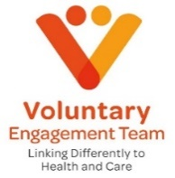
Lincolnshire Voluntary Engagement Team
Virtual Engagement Meeting

Date: 19th November 2024
Time: 10.00 am – 12.00 pm

Join the meeting now
Agenda

Theme: Research – simply looking at things in more detail to understand them better! Hear about exciting things happening as well as from organisations who use research and engagement in their day-to-day work!

10.00 | Welcome and Introductions
10.10 | Paul Holmes – Lincolnshire ICS Innovation Lead
10.25 | Emily Ward – Research Engagement Network Programme
10.45 | Navaz Sutton – HW Lincs
10.55 | Short Break
11.05 | LVET Updates
11.15 | Naetha Uren – Recovery Coach Academy
11.25 | Lizzie Lamming – National Energy Action (NEA) Warm Homes Healthy Futures project aimed at households/groups with health conditions
11.35 | Sector Challenges and Opportunities,  Members Items/ Q and A
11.55 | Roundup and Close of Meeting
12.00 | End of Meeting

