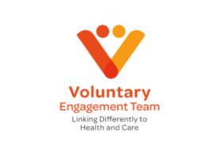
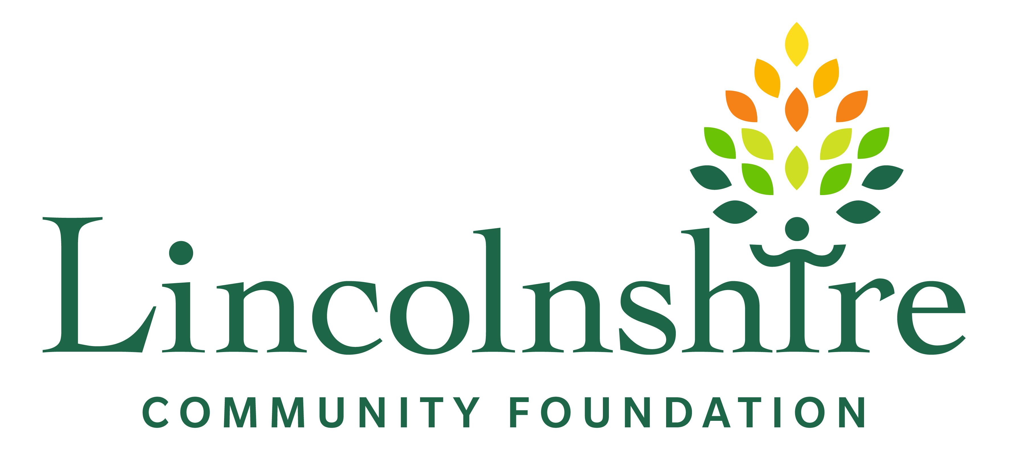

Health, Social Care and Wellbeing Research Fund
Application Form

PRIOR TO COMPLETING THE APPLICATION, PLEASE REFER TO GUIDELINES ON WWW.LVET.CO.UK
Please continue on extra sheets if necessary

GRANT APPLICATION FORM (up to £5000) | Return to Lincolnshire Voluntary Engagement Team via email:  Emily.ward@lvet.org  If you’re unable to email the form, please print and return via post to LVET, c/o St Barnabas Hospice, 36 Nettleham Road, Lincoln, LN2 1RE  07888 330294 www.lvet.co.uk
Name of Applicant:
Organisation Name (if applicable):

Address:
Telephone:
Email/website:
(if applicable)
Charity / Company Number:
Project Title:
Project Summary:
What would you like funding for? What would you hope to achieve? Include the project start and finish dates.

Maximum 200 words
Your local community:
Tell us about your relationship with your local community. How will you engage with local people? Who do you want to work with in your local community? Who are your local community?
Maximum 200 words
Why is there a need for this?
Tell us how you identified the need for this project or activity. Provide details of the conversations that were carried out and describe why it is important to act and who will benefit?
Maximum 200 words
The difference you hope to make:
How will the project have a positive impact on the health, social care or wellbeing on the community or improve health and social care practices? How does the project relate to either 1) a health or social care topic, 2) a specific role or 3) the experience of living with a specific condition
Maximum 200 words
Your impact:
How will you capture the difference your project makes? How will you know the research project has been a success? What will change for people in your community?
Maximum 200 words
Project Management:
Are you working with a local organisation who may be willing to hold funds on your behalf? If so, tell us more about them (registered charity, club etc); details of committee or trustees; when the group started, no of staff/ volunteers.
We will let you know if we need to have sight of their governance documents.

If not, we might be able to help with this.
Maximum 150 words
Outline of
project costs:
How much you want from us (maximum £5000 and smaller bids welcome); tell us how you intend to spend funds. If there is a shortfall, how will you raise the rest?

Maximum 100 words
How the project will continue when
funding ends:
Explain, if applicable (this may be a one-off project). Include whether you will explore further opportunities for other types of funding, time to reflections etc.
Maximum 150 words

Referee (if you’re an individual):
Contact details of one referee - prominent in your local community.

Supporting Documents

Please include the below documents when you submit your application unless otherwise stated. If you are an individual, please tick the relevant box below.

Your organisations latest set of annual accounts, or an income / expenditure spreadsheet, or 3 months worth of bank statements if open less than 1 year
Your organisations set of rules / terms of reference / constitution if not registered on charity commission / companies house (as we will find these)
A copy of your safeguarding policy
A copy of your insurance
I am an individual

Conditions of the grant

Please sign below to indicate your acceptance of a grant from Health, Social Care & Wellbeing Research Fund in the event it is successful:

1. The Grant, administered by the LVET in conjunction with Lincolnshire Community Foundation, and will be used for the purpose outlined in the application. Any changes to the project must be agreed with LVET.

2. We / I will spend the grant by 31st July 2025 or any other timetable set by LVET and will complete and submit a short Impact Report within two months of the end of the project. Failure to do so, may jeopardise the success of any future funding applications. Any grant money not spent on the project will be repaid to LVET. We / I agree that the impact report can be made publicly available.

3. We / I accept that the application form will be shared with a grant panel made up of people living in Lincolnshire ( a combination of members of the public and employed by local organisations).
4. We / I will not dispose of grant-aided equipment without LVET’s agreement. Any money thus raised will be refunded to LVET.

5. We / I will not change our rules, aims or constitution without LVET’s agreement.

6. We / I I will use the relevant logos and branding guidelines notified to me in all promotional material relating to the funded project and acknowledge this contribution in relevant publicity and publications, as well as acknowledging this funding via social media networks.

7. We / I accept that LVET, and the REN steering group, may use this project for publicity purposes.

9. We / I will keep all receipts and accounts relating to grant-aided expenditure for six years from receipt. These records to be made available to LVET if requested.

10. We / I will not bring the fund, or LVET, into disrepute and undertake to return all funding should it be determined that I have done so.

11. We / I confirm that if relevant we have a valid Safeguarding Policy and will send this along with the application form.

12. LVET will require repayment of all or part of the grant if the project is abandoned for any reason or if there is non-compliance with any of these conditions.

Signature:
Name:
Date:

Please submit via email, including all supporting documents to Emily Ward at emily.ward@lvet.org. Or if you are unable to email, post to LVET C/O St Barnabas Hospice, 36 Nettleham Road, Lincoln, LN2 1RE – 07888 330294

